- Attached 5 Pupils in that David Griff & Jonathan Griff were siblings
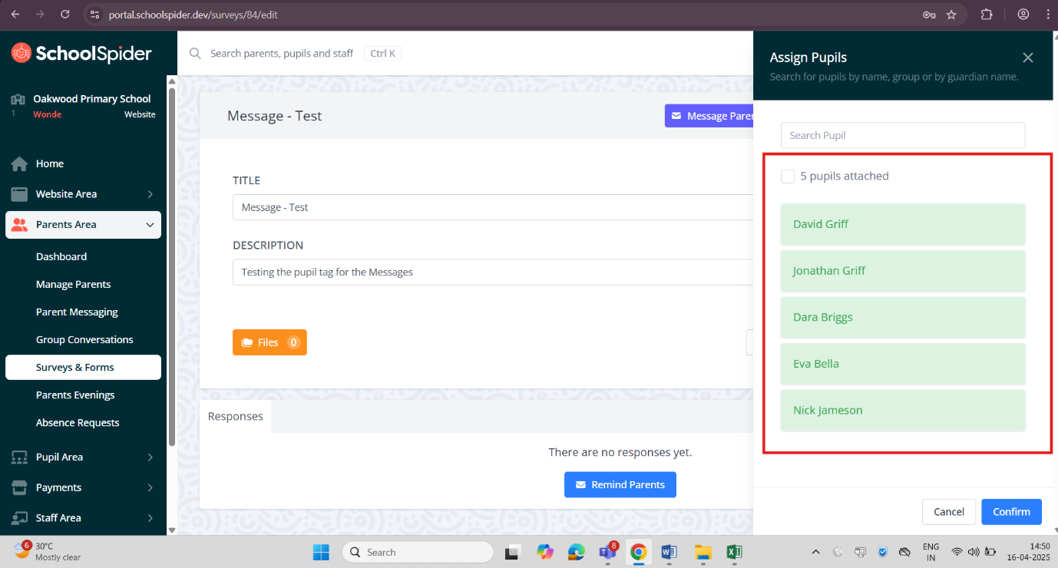

- Published Surveys & Forms to all the 5 Pupils and clicked Send To All Parents
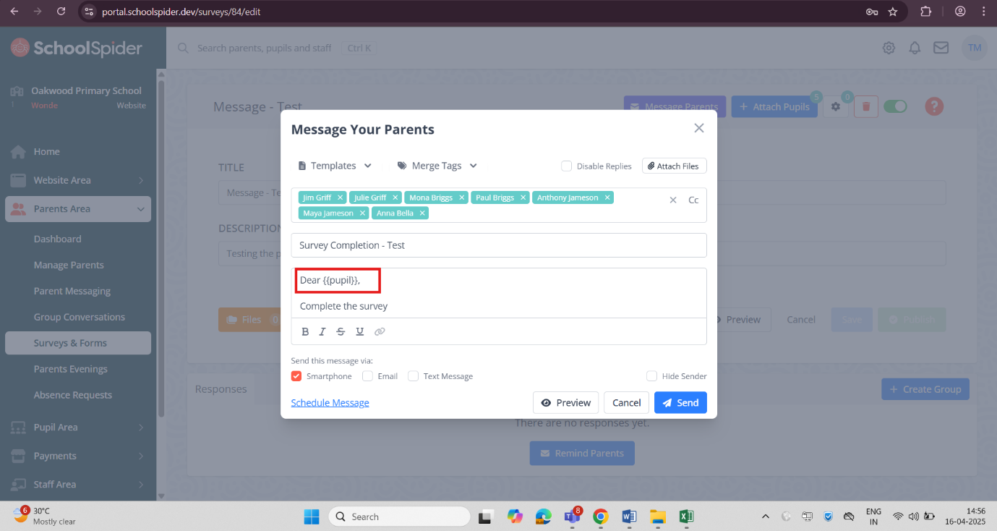

- Pupil – 1 Received Message & Completed the Survey
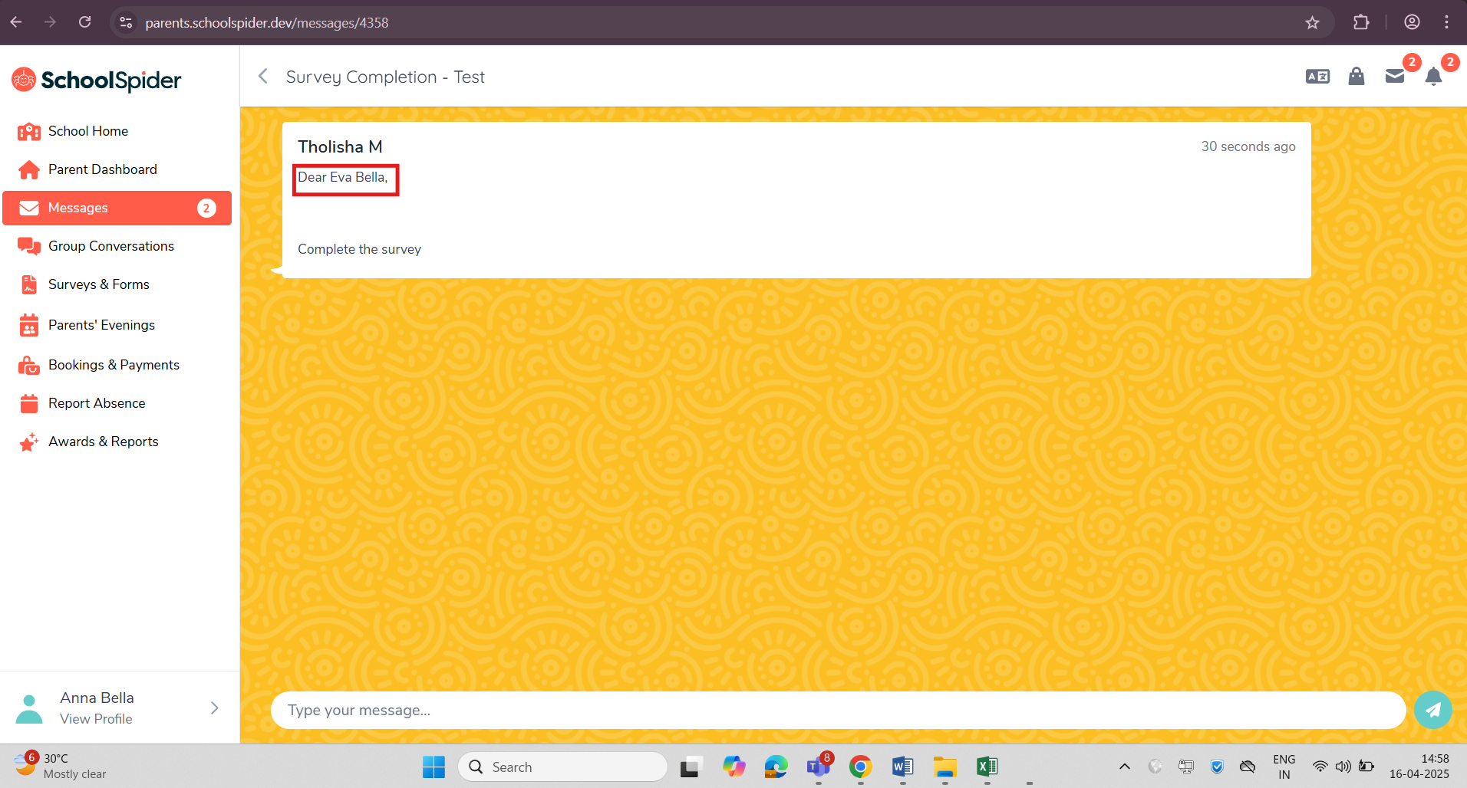
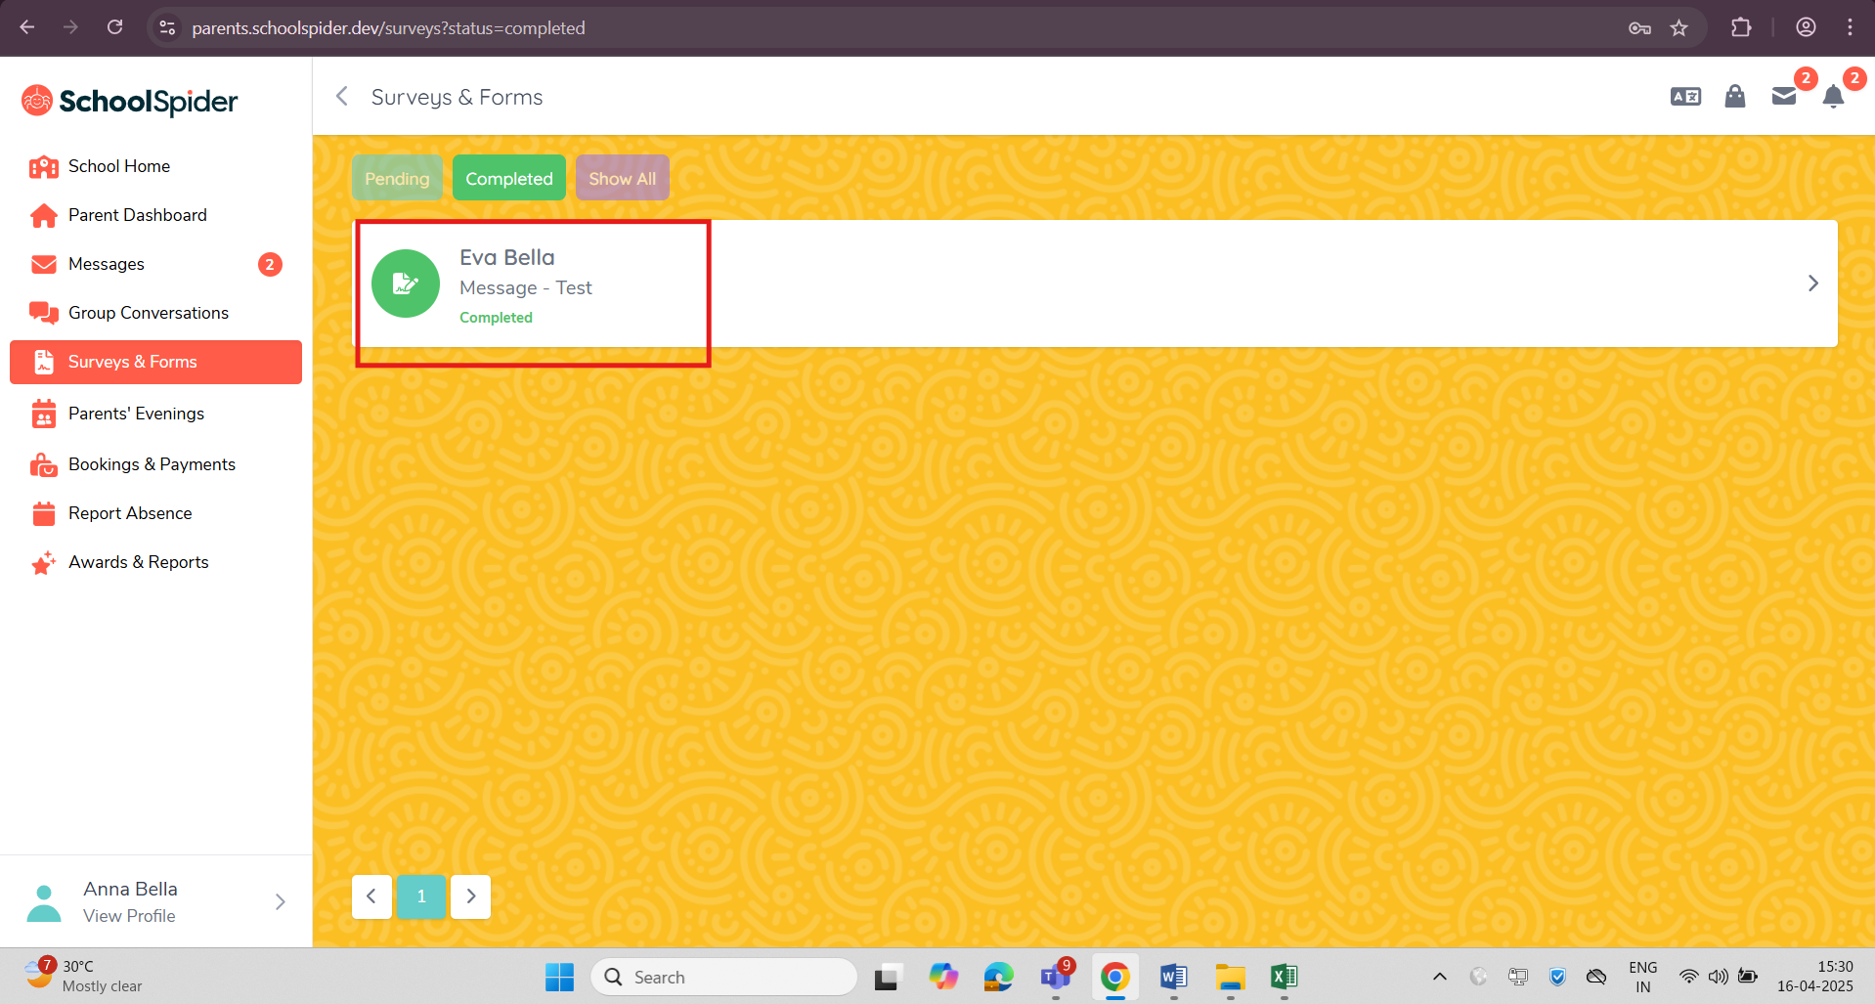

- Pupil – 2 Received Message & Completed the Survey
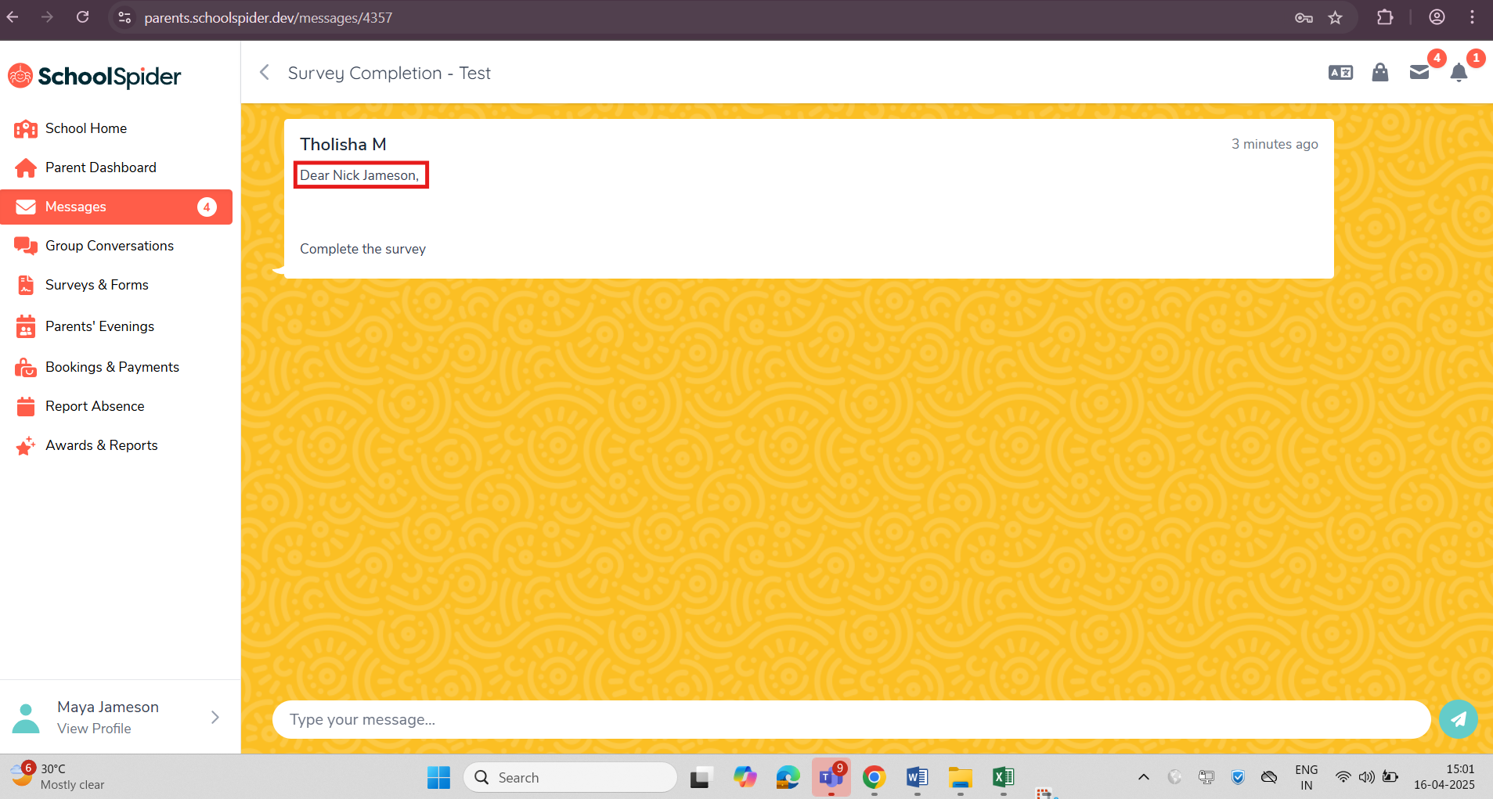

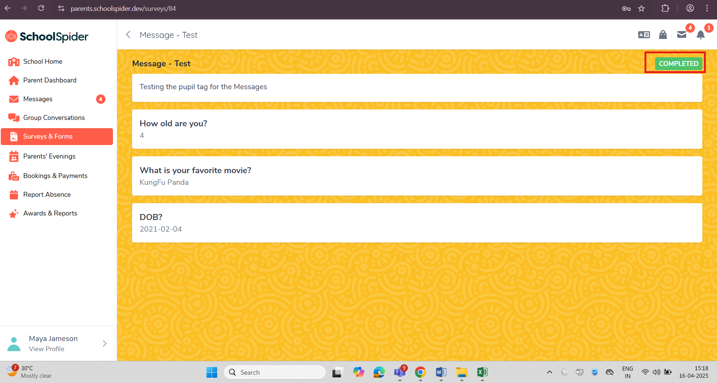

- Pupil –3 Received Message & Completed the Survey
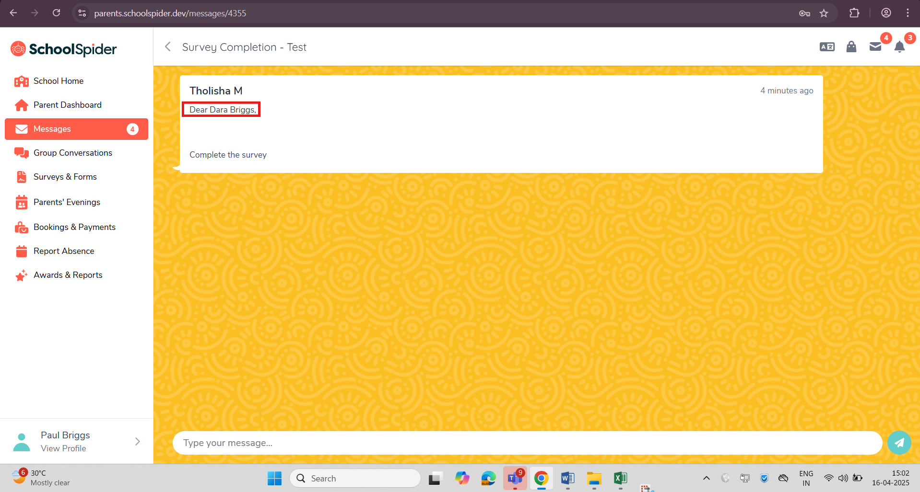
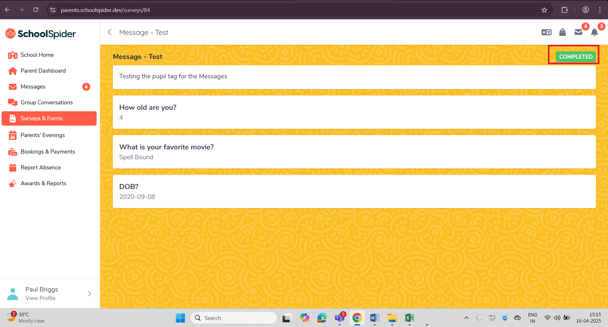

- Pupil4 & Pupil5 – Completed the Survey only for 1Pupil(David Griff)
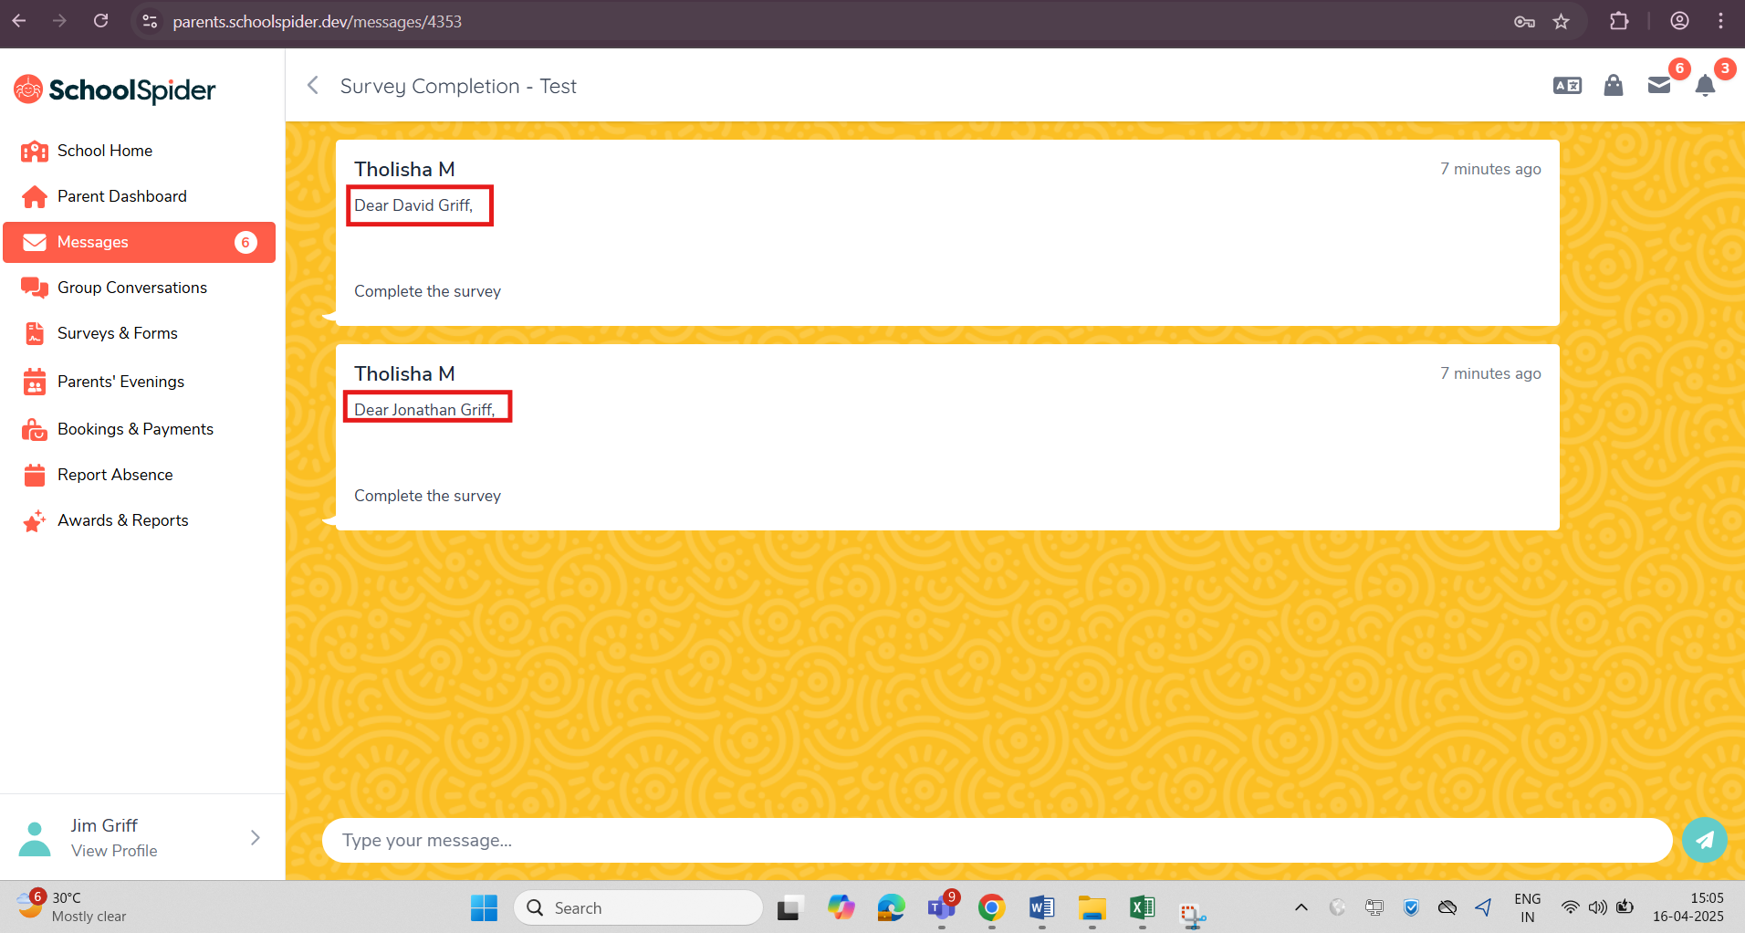
- Completed Survey for 1Pupil(David Griff) among 2Pupils
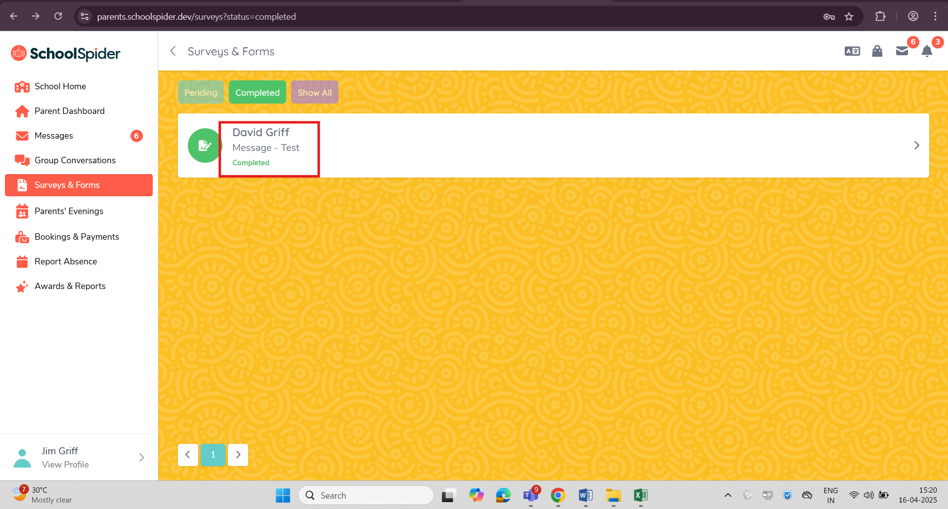

- Haven’t submitted for the other pupil
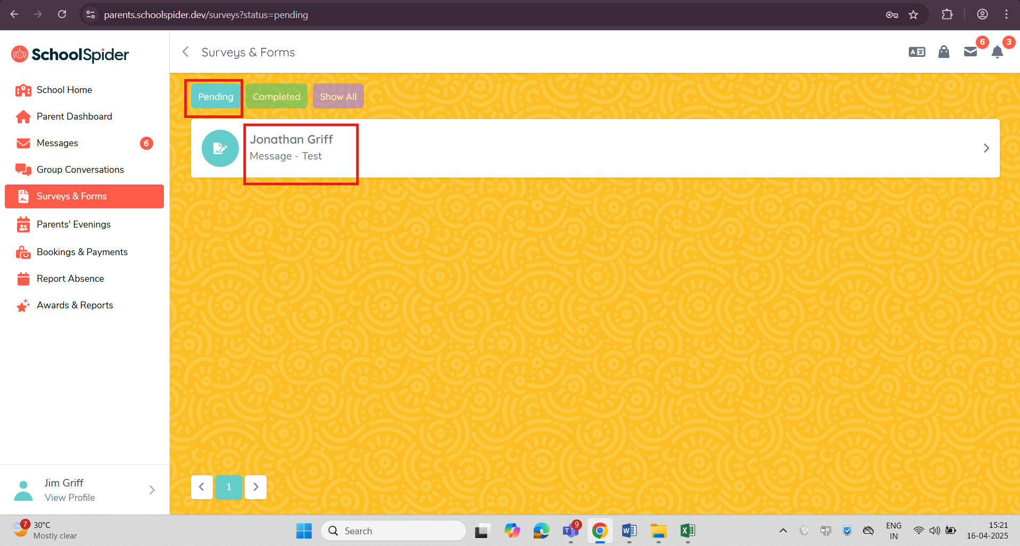

- Received the response from parent and showing the result as the Jonathan Griff has not submitted the Survey among the siblings.
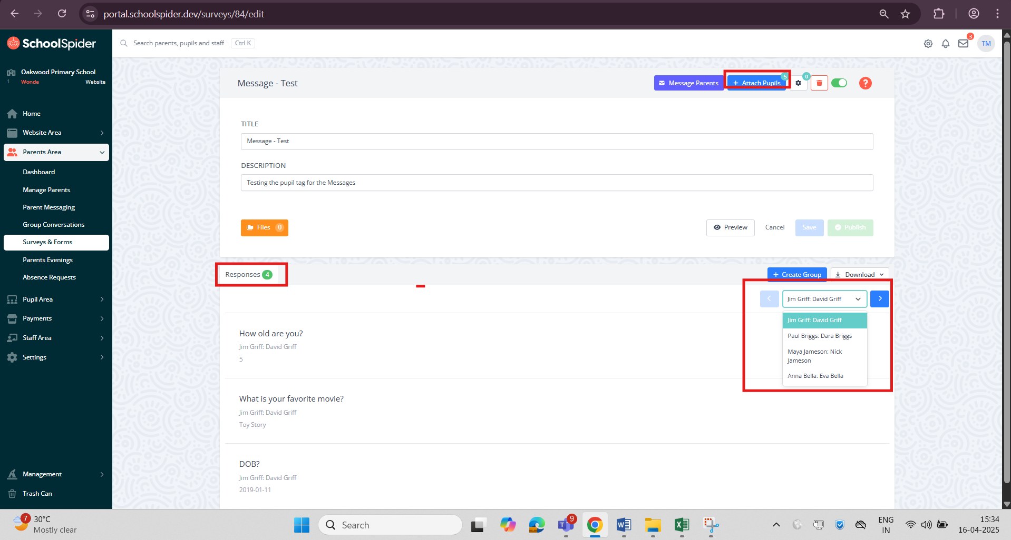

- Message Parents – Send To Answered

